
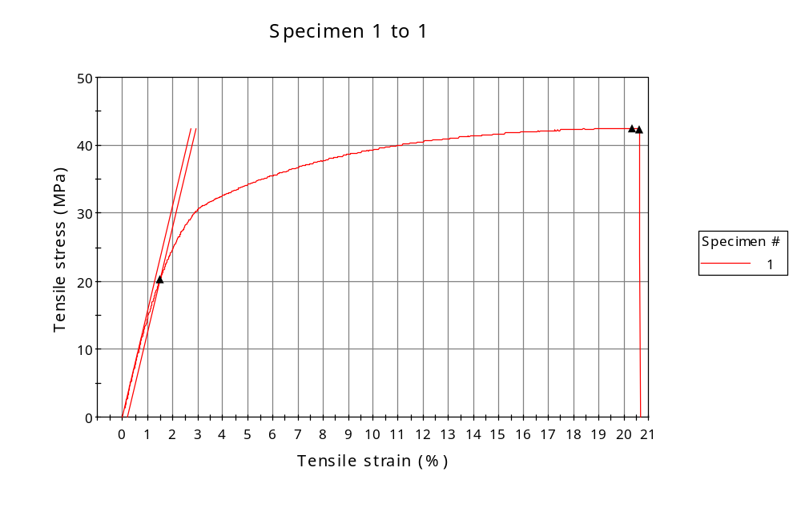
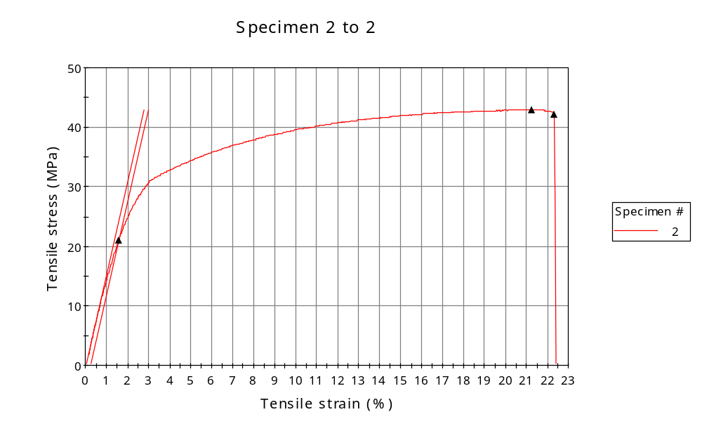
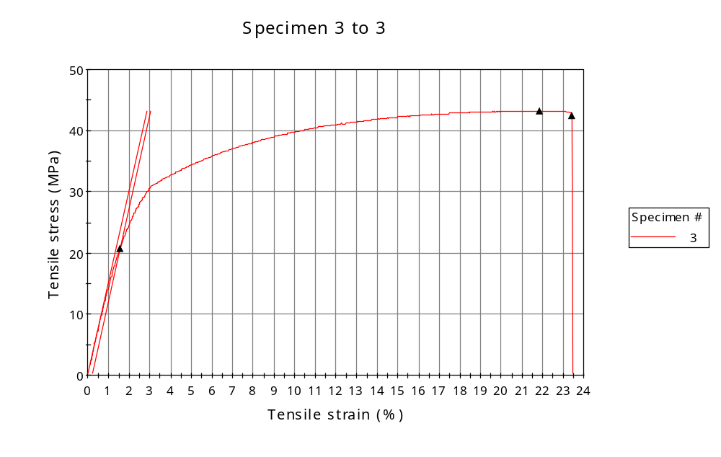
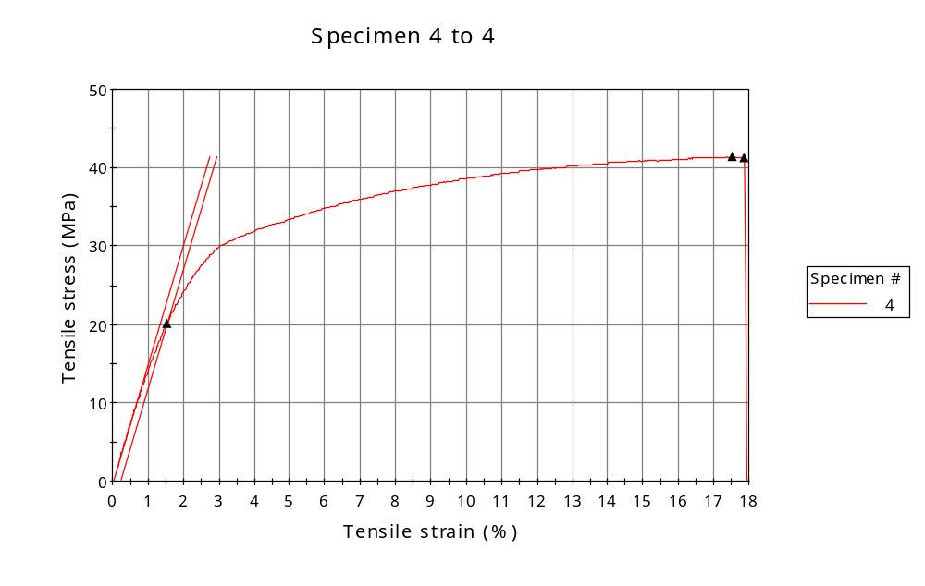
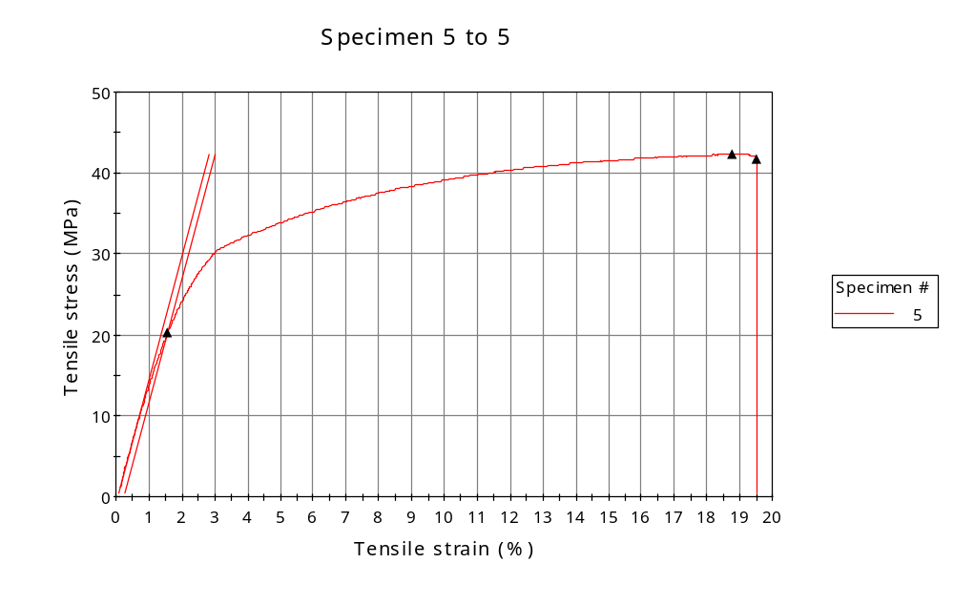
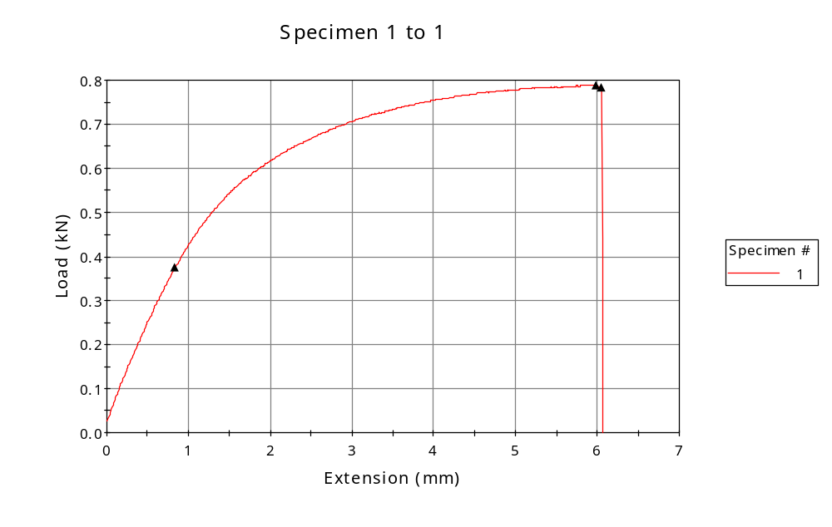
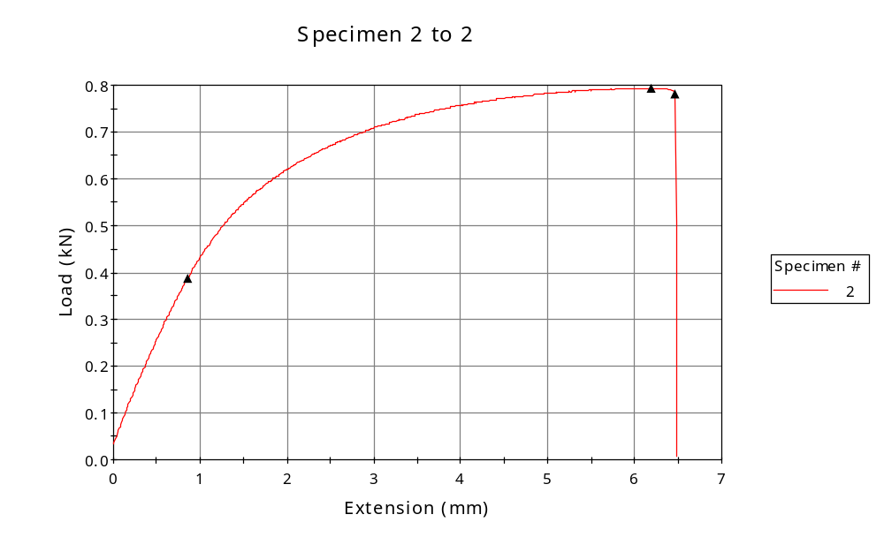
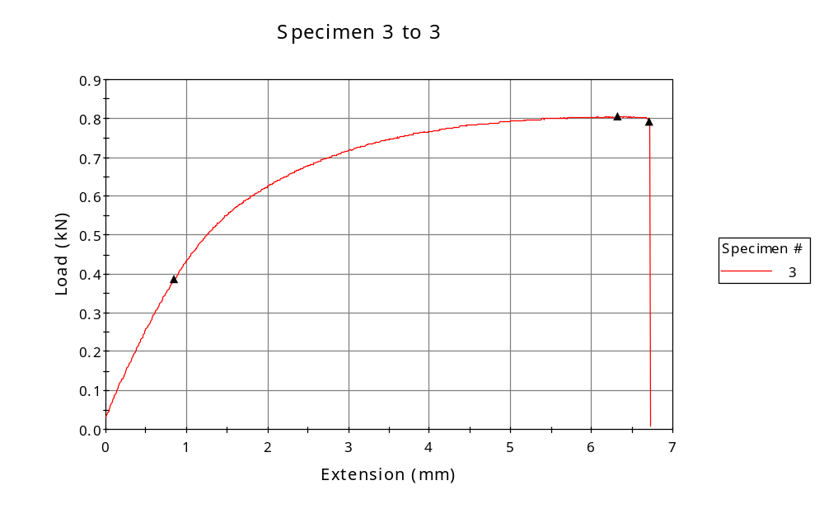
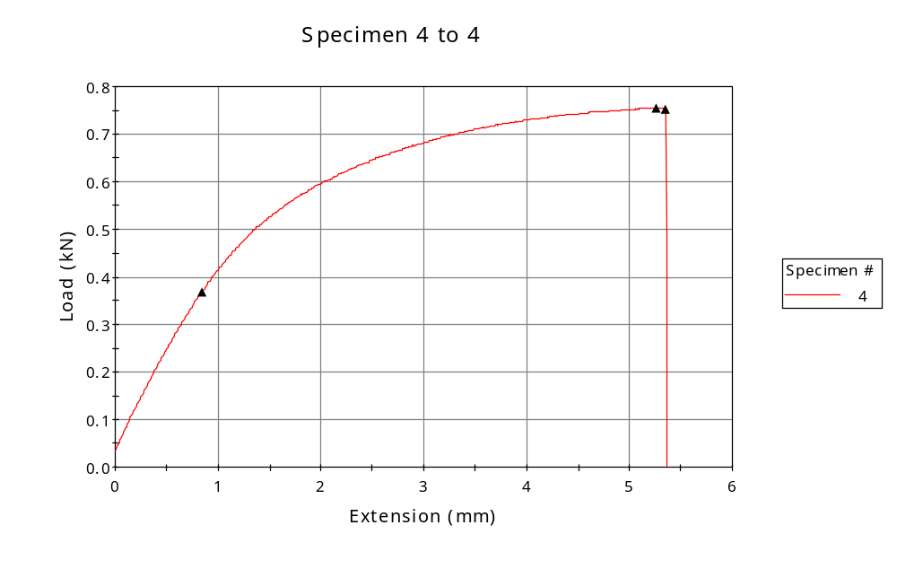
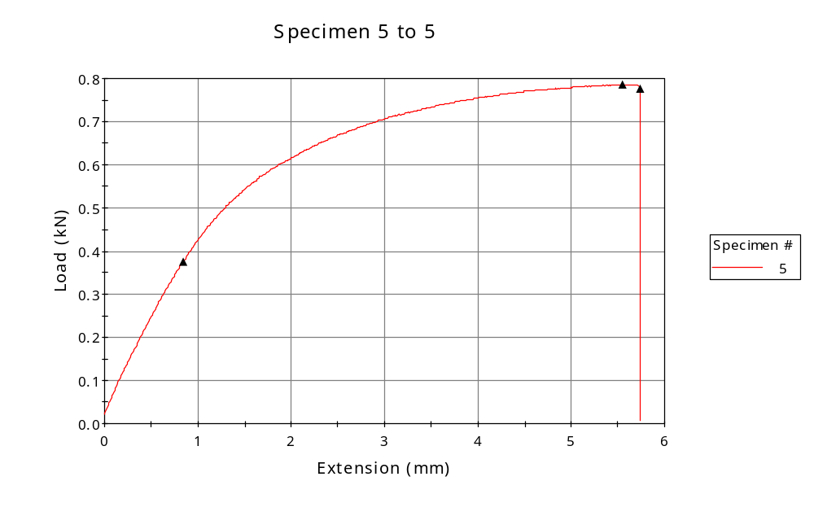

 | CP ID | Length  (mm) | Width  (mm) | Thickness  (mm) | Modulus (Automatic Young's)  (MPa)
1 | CP-SLS_ZY6_01 | 25.00 | 5.90 | 3.14 | 1565
2 | CP-SLS_ZY6_02 | 25.00 | 5.89 | 3.14 | 1556
3 | CP-SLS_ZY6_03 | 25.00 | 5.92 | 3.14 | 1520
4 | CP-SLS_ZY6_04 | 25.00 | 5.89 | 3.10 | 1515
5 | CP-SLS_ZY6_05 | 25.00 | 5.90 | 3.15 | 1529
Maximum |  | 25.00 | 5.92 | 3.15 | 1565
Minimum |  | 25.00 | 5.89 | 3.10 | 1515

 | Load at Fy ( 0.2 %) - LE  (kN) | Tensao em Fy ( 0.2 %) - LE  (MPa) | Deformacao em Fy ( 0.2 %) - LE  (%) | Forca Max  (kN) | Tensao na Forca Max - LR  (MPa)
1 | 0.376 | 20 | 1.490 | 0.788 | 43
2 | 0.388 | 21 | 1.570 | 0.794 | 43
3 | 0.386 | 21 | 1.557 | 0.804 | 43
4 | 0.368 | 20 | 1.541 | 0.755 | 41
5 | 0.375 | 20 | 1.561 | 0.786 | 42
Maximum | 0.388 | 21 | 1.570 | 0.804 | 43
Minimum | 0.368 | 20 | 1.490 | 0.755 | 41

 | Deformacao na Forca Max - LR  (%) | Forca na Forca na Quebra - LQ  (kN) | Deformacao na Forca na Quebra - LQ  (%) | Final length  (mm) | Final width  (mm)
1 | 20.352 | 0.784 | 20.618 | 119.00 | 6.82
2 | 21.235 | 0.780 | 22.335 | 119.00 | 6.82
3 | 21.855 | 0.790 | 23.423 | 119.00 | 6.82
4 | 17.544 | 0.752 | 17.878 | 119.00 | 6.82
5 | 18.776 | 0.776 | 19.509 | 119.00 | 6.82
Maximum | 21.855 | 0.790 | 23.423 | 119.00 | 6.82
Minimum | 17.544 | 0.752 | 17.878 | 119.00 | 6.82

 | Alongamento
1 | 3.76
2 | 3.76
3 | 3.76
4 | 3.76
5 | 3.76
Maximum | 3.76
Minimum | 3.76

